AUTUMN 2025
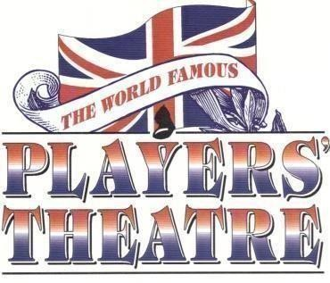
Our Next show

***Friday, 31st October at the CAA at 7.15pm***
A *HALLOWEEN* SPOOKY *NEW FACES*
MUSIC HALL

*Welcome to a spine tingling soiree of Music Hall* Where ‘gaslight’ meets ‘ghostlike’ and new talent conjures up Victorian, chills, thrills and chuckles to present a Halloween of haunting harmonies and devilish delights!!

*The past comes back to play*



Entry is by donation: £20 is suggested to include a glass of something fizzy !

Please email us if you would like to reserve a seat

The Players continue to be dedicated to keeping the Music Hall genre alive and we are most grateful to those who have contributed to our New Faces fund , especially our two honorary patrons, Gerald Glover and John Cliff .

CONTACTING THE PLAYERS our email address : team@playerstheatre.co.uk.

www.playerstheatre.co.uk

THE PLAYERS RETURN TO WILTON’S MUSIC HALL
**********************************

 LOVE IS IN THE AIR* FEB 12th at 7pm
With our special surprise guest star , together with the hugely talented cast from London’s famous Players Theatre ,we toast to LOVE in all its splendid Victorian enchantment.

With glorious Wilton’s as our backdrop, a jewel of Victorian theatrical heritage, we invite you ladies and gentlemen, to fall head over heels for the charm of yesteryear.

Join us for ballads, bawdy banter, amorous antics, toe tapping tunes and heart fluttering hilarity, all steeped in velvet and gaslight, Victorian style.
Just don’t forget your heart strings, we will be tugging them all evening!

*LOVE, LACE and LAUGHTER*

*A LOVE AFFAIR WITH THE MUSIC HALL*

PRODUCED & DIRECTED BY JAN HUNT

****Booking opens 11th October****

Details : Wiltons.org.uk

********************************************
**** Please see attached flyer ****
Another date for your diary :
Our wonderful producer Jan Hunt’s company Paper Moon is back in Leeds City Varieties on May 2nd 2026 .
Something else not to be missed

